SEABCRU Flying Fox Workshop

Hat Yai, Thailand July 7-8, 2012

List of Participants

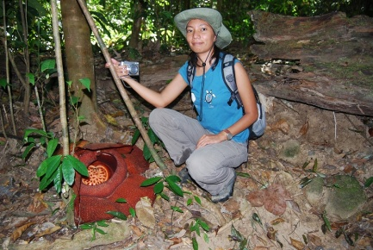Sheema Abdul Aziz

Peninsular Malaysia

I have a BA in Archaeology and a MSc in Conservation Biology. My involvement with bat research began when I volunteered on Tigga Kingston's Malaysian Bat Conservation and Research Project in Krau Wildlife Reserve, Malaysia. I then went on to conduct a mark-recapture analysis of Tigga's data for my MSc dissertation, investigating temporal changes in population sizes of 3 Microchiropteran species. I have worked for TRAFFIC Southeast Asia, Wild Asia and WWF-Malaysia, gaining experience in aspects such as wildlife monitoring, trade and poaching, forestry and HCVF, protected area management, and indigenous livelihoods. I am now working under Rimba, a research group I co-founded focusing on Malaysian conservation issues (<http://myrimba.org>), whilst I prepare a PhD proposal to study flying foxes in Peninsular Malaysia. Earlier this year Rimba scored a small victory when we successfully lobbied the Terengganu state government to impose a ban on hunting of flying foxes (which is legal in Peninsular Malaysia through a licensing system). I am especially keen to investigate ecosystem services provided by fruit bats (both ecological and economic value of pollination and seed dispersal), as well as the hunting and trade of flying foxes.

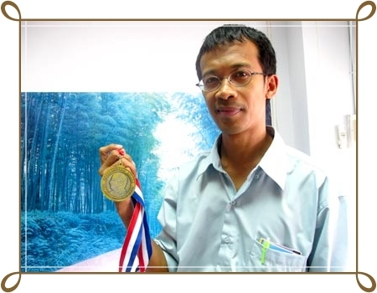Sara Bumrungsri

Department of Biology, Prince of Songkla University, Thailand

I grow up in fruit orchards in central Thailand. After have the first degree in forestry from Kasetsart University, I work with a bat expert, Dr. Mark Robinson, for surveying bats in Thungyai-Huai Khakhaeng Wildlife Sanctuaries, western Thailand. Six months of hard work made me find my way. I decided to do a master degree in bat ecology, its roosting ecology. After having finished my thesis, I ran into PhD in Scotland with Prof. Paul Racey where I carried out my research on foraging ecology of a common fruit bat,Cynopterus brachyotis, in south-east Thailand. I finished my degree in 2002, and start my intensive work as a lecturer in Department of Biology, Prince of Songkla University.

My research mainly with fruit bat and pollination ecology. I focus mainly with Eonycteris spelaea, an

nectarivorous bat, which my student working further in foraging ecology of it and also other pollination

ecology of plant that are pollinated by it, e.g. Oroxylum. After having part of south-east Asian bat committee and have difficulty in designing bat conservation status, I have been part of the team, working with Dr. Paul Bates from the Harrison Institute, starting a bat taxonomic initiative in mainland SE Asia. Students from Thailand, Lao PDR, and Cambodia join the project and did a master thesis in my university. The momentum is still going on, some students do a further PhD study.

I also interest in bat ecology, two students work on foraging and roosting ecology of Kitti’s hog-nosed

bat, Craseonycteris thonglongyai, with my former advisor, Prof. Racey, and Prof. Gareth Jones as the

committee. I myself also interest in bat echolocation where we collect calls of most bats in Thailand in

accompany with taxonomic study. All material deposited in Princess Maha Chakri Sirindhorn Natural

History Museum, PSU. My research site mainly in southern Thailand from Satun to Narathwat.

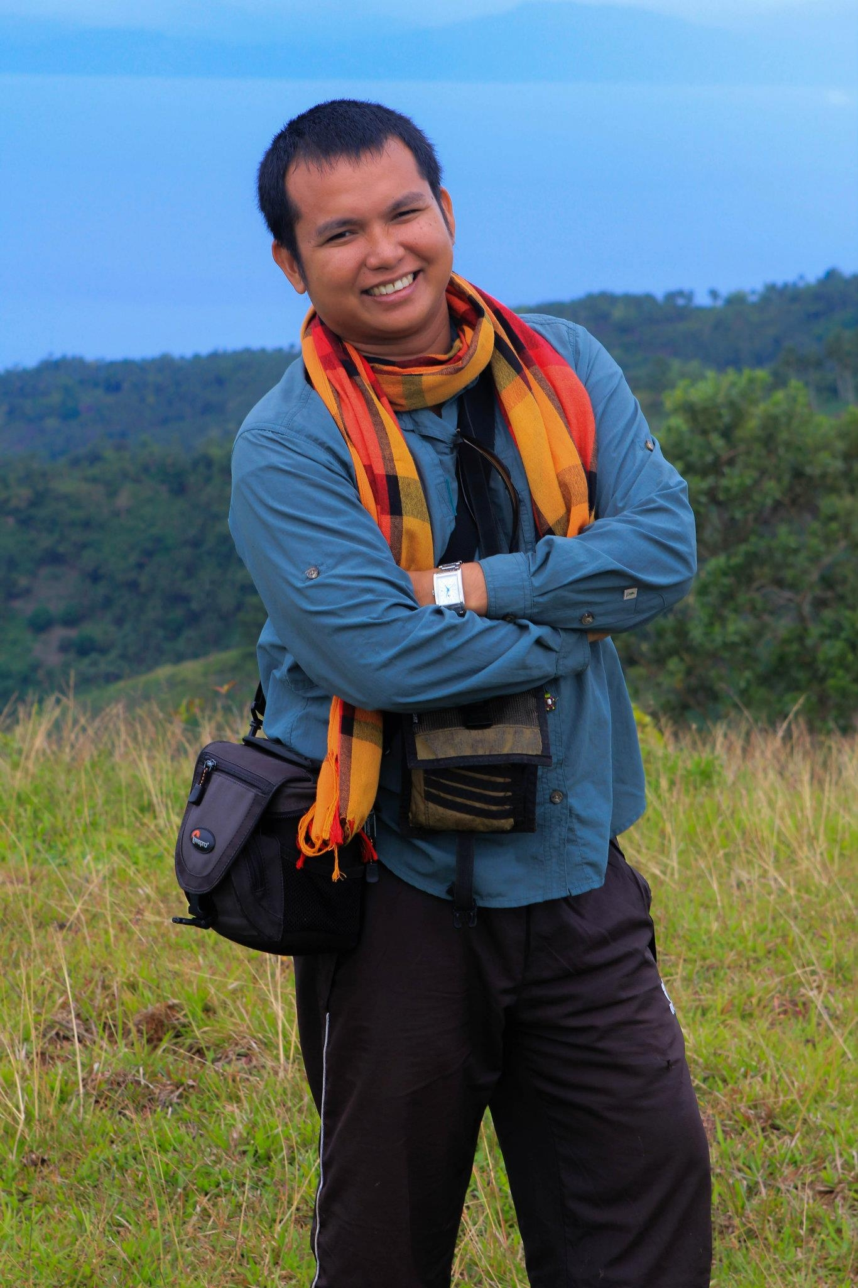Apolinario B. Cariño

Philippines

My work on bats began in 1995 through the conservation breeding program of threatened flying foxes in the Philippine at the Silliman University Center for Tropical Conservation Studies.  Since then I was trained to work for the implementation of community-based biodiversity conservation for sustainable development activities to some 20 People’s Organizations (mainly farmers) around the Mt. Talinis and Twin Lakes are in the southeastern part of Negros Island.  It is also through this Center that I met a lot of opportunities to work with other bat enthusiasts leading to the implementation of a pilot project on flying foxes, cave and forest bats management and conservation.

We used the results from these studies in the establishment of a community-based conservation education program for bats.  Particularly, in the creation of a bat documentary depicting the current status, ecology, and conservation program of bats in the country in collaboration with a local media, protected area managers, local government units, and the Department of Environment and Natural Resources – Protected Areas and Wildlife Bureau.   Furthermore, in cooperation with other organizations, we were able to establish some artistic ways of sharing bat conservation awareness to the public through a youth group advocating through theatre and arts and bat festivals that has been sustained by some local government units.

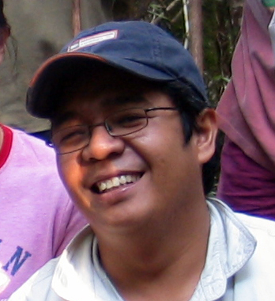

Mariano Roy M. Duya “Aloy”

Institute of Biology

University of the Philippines Diliman

Philippines

A biologist by training and have worked on the biogeography and conservation of Philippine mammals for more than 15 years. I am currently working on a project with a private company operating geothermal facilities in the country. As part of the project, we are monitoring colonies of flying foxes located within the geothermal reservation. The main objective of the monitoring project is to identify the species and monitor the population of flying foxes for habitat management, conservation awareness and for the companies’ decision makers to ensure that development activities within the facility and adjacent areas do not endanger the roost sites and the species. In addition, we are embarking on a study on habitat use of the flying foxes using telemetry and seed trapping. Results of the study will be used by the company to enhance their reforestation efforts by planting indigenous tree species identified as food preference of flying foxes and protection of the species in their foraging area.

Noellie Gay

Master Student, Epidemiology;

Faculty of Veterinary Medicine, Kasetsart University, Bangkok, Thailand

I work on Macro-Ecology of Bat diseases.

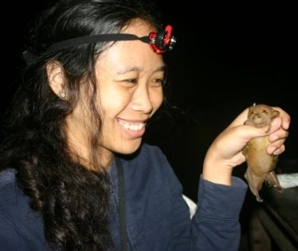Rai Kristie Salve Gomez

Philippines

I am a BS Biology of the University of the Philippines in Mindanao, Davao City. The first time I've become aware of bats was for my undergraduate thesis and I got the chance to see the flying foxes in Malagos Watershed, Davao City. The first time I saw a flying fox roost, I was totally fascinated and just knew that I had to know more about these amazing animals. Then in 2004, I was fortunate to be part of the Bat Count Workshop in Subic by Bat Count Philippines and get to know people who are working for flying foxes. After the workshop, together with the Department of Environment and Natural Resources, we conducted education awareness in surrounding communities of Malagos Watershed. I've always been interested on flying fox behavior and ecology, but most importantly to be involved in flying fox conservation activities.

Currently, I've been involved more with work on Philippine Cave Bats than flying foxes. But recent news about flying foxes has been so disheartening (hunting for food, game hunting, lack of awareness, and cruelty to flying foxes). From these reports, I knew that we have to do something for flying foxes NOW. So together with the Department of Environment and Natural Resources and academe, we plan to start monitoring the flying fox population in Malagos Watershed and come up with education activities for flying fox conservation.



Melvin Gumal

Malaysia Program, WCS; Sarawak, Malaysia

PhD – Ecology and conservation of *Pteropus vampurus natunae* in Sarawak

(1997 – 2001). Currently Director of Malaysia Program for WCS since

2003. Previously, head of Sarawak’s National Parks and Wildlife Division’s Conservation Education and Interpretation Unit.

A) **Research on flying foxes** – radio tracking Pteropus spp.

B) **Useful conservation deliverables on flying foxes to date** –

a. listed as a protected species in Sarawak (1998);

b. commercial hunting ban on the species in Sarawak (1998) and Johor (2009);

c. helping to get the maternity roosts at Sedilu gazetted as a national Park (Sedilu NP ‐ 2010). Other maternity roosts such as Sarang and Pulau Bruit are in their final gazettement. Before these, there is only one gazetted maternity roost in Sarawak, i.e. at Loagan Bunut National Park

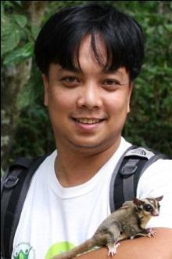

Philip Godfrey Jakosalem

Philippine Biodiversity Conservation Foundation, Inc.

Locally known as Godo, he hails from the island of Cebu in central Philippines. He was first introduced in doing conservation education work while still doing his BSc in Biology. Feeling inclined to pursue conservation work he first worked with Department of Environment and Natural Resources Office in Region – 7 from 2000-2002 and with Cebu Biodiversity Conservation Foundation Inc. as a Field Projects Officer in 2003 - 2010. This was where he got the opportunity to conduct research expeditions and intensive field course training on flying foxes, cave bats and forest bats. Through various training and experience, he became instrumental in facilitating the protection of the largest roosting sites of flying foxes in Cebu, Philippines. He pursued his Master’s Degree in Applied Ecology and Conservation in University of East Anglia in UK with a fellowship grant from Ford International Fellowship Program. He is currently involved with Philippines Biodiversity Conservation Foundation Inc. directly supervising Conservation Science Program conducting research and assisting the implementation of conservation programs in at least 16 Key Biodiversity Areas in the Philippines.

Vivien Lee

National University of Singapore

Hi everyone, my name is Vivien. I am currently an undergraduate student at the National University of Singapore. I major in Life Sciences and intend to specialise in Environmental Biology. Singapore used to have large populations of flying foxes in many areas but their status here has now been reduced only to that of a visitor species. I will be working with my mentor and supervisor from National Parks Board, Mr Benjamin Lee on a publication compiling recent flying foxes sightings in Singapore.

On top of that, I am also working on bats for my undergraduate research project, which examines ectoparasite load. In addition, I am also working under Mr Ian Mendenhall on the NIHA project(NUS Initiative to Improve Health in Asia), examining bats as a disease vector and how they may affect the human population in urban Singapore. I hope that I can learn more about flying foxes as well network with other biologists in this part of the world in the SEABCRU workshops.

Vu Long

Center for Biodiversity and Development, Institute of Tropical Biology, Viet Nam

I have been interest in bats since I was a boy. My first academic study about bats was my graduated thesis on bats inventory in a Ta Kou mountain, BinhThuan province. After having Bachelor degree in Ho Chi Minh city University of Science in 2010, I have worked for Center for Biodiversity and Development (CBD), Institute of Tropical Biology (Vietnam) as a researcher in Mammal research team. In this agency, I continue to study about bats in South Viet Nam. My experiences and data of Flying foxes come from several biodiversity surveys conducted by CBD in Lower Mekong delta, where I was the only one working on bats. After these surveys in Lower Mekong Delta, I realized that the Giant flying Fox (*Pteropus vampyrus*) population in here has facing very serious threats from hunting and losing habitat. In order to develop a good conservation programs for this threatened species, I want to focus to study about their feeding ecology and habitat selection in my next academic degree. I also interest in Flying foxes evolutionary and systematic.

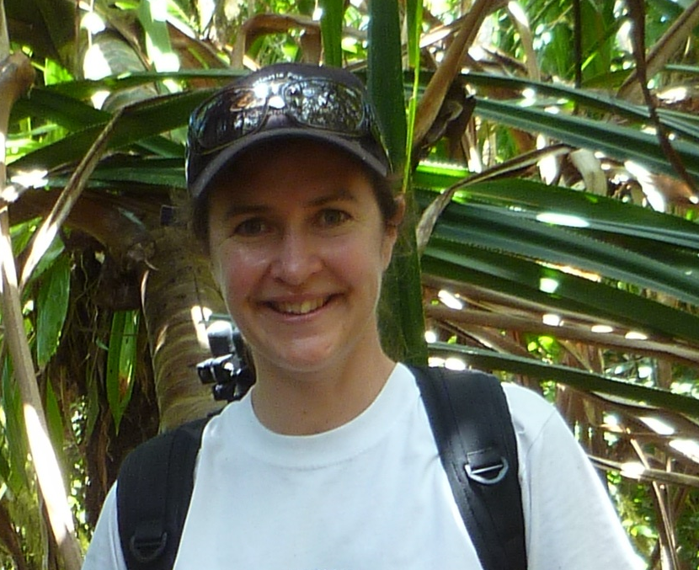 Tammy Mildenstein

University of Montana, USA

I have been involved in fruit bat conservation research and education in Southeast Asia since 1997, when I conducted my Master’s research on habitat and dietary selection on endangered flying foxes in the Philippines.  I am currently finishing my Ph.D. dissertation at the University of Montana on the population abundance and distribution of *Pteropus vampyrus* and *Acerodon jubatus* and the sensitivities of these species to anthropogenic disturbance, such as habitat loss and hunting.  I am also in the process of developing a protocol for non-invasive collection and extraction of fruit bat DNA material to promote more conservation-friendly genetic study of fruit bats.

During the pursuit of my PhD, I have pursued many non-academic, but complementary, fruit bat conservation initiatives. These include the development of a community-based fruit bat monitoring program in the Philippines, mentoring Filipino and American undergraduate biology students, and conducting education and awareness campaigns, capacity-building/training, and priority-setting workshops.  I have pursued opportunities to use my Philippines work as a model to promote conservation research in other countries.  I was asked to serve as a Scientific Advisor on the Mariana Fruit Bat Recovery Team, and in that role, I have contributed to the U.S. Fish and Wildlife Service Recovery Plan for this endangered species and have developed an abundance assessment and monitoring protocol for this species across its range in the Mariana Islands. Finally, I am coordinating the revision of the IUCN Old World Fruit Bat Conservation Action Plan which will play a vital role in promoting and coordinating future research and conservation across this largely threatened taxon.

Thongchai Ngamprasertwong

Department of Biology, Faculty of Science Chulalongkorn University, THAILAND

C.E. Nuevo

Philippines

I graduated from University of the Philippines at Los Banos with a Bachelor’s degree in Biology. My field work experience comes from working on Acerodon jubatus and Pteropus vampyrus in Subic Bay, Philippines with Tammy Mildenstein, where I eventually became a junior author to the paper, “Habitat selection of endangered and endemic large flying-foxes in Subic Bay, Philippines,” published in 2005 by Biological Conservation. I also worked with Bat Count Philippines and helped count bats in the Subic area. Currently, I am working on revising IUCN’s Old World Fruit Bats Action Plan with Paul Racey, Simon Mickleburgh, Tammy Mildenstein.

My role in the SEABCRU is to provide support to the Fruit Bat Priority Group Leaders and the IT Project Manager in managing the website.

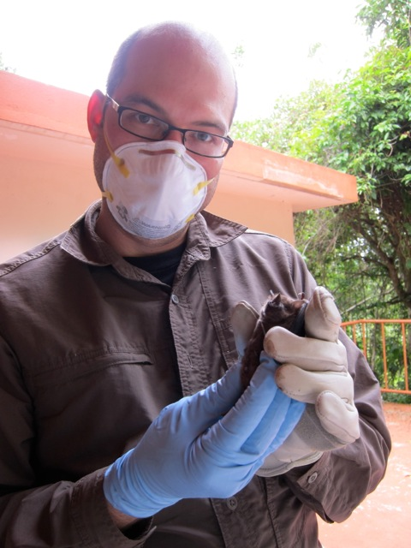Kevin J. Olival

EcoHealth Alliance, New York, USA

I have worked with on issues related to bat conservation and disease ecology for the past 10 years. I describe myself as an ecologist and evolutionary biologist with a passion for bat conservation and emerging infectious disease research. My dissertation at Columbia University focused on the population genetics and phylogeography of large fruit bats (Genus *Pteropus*) in Southeast Asia, with implications for Nipah virus dynamics and emergence and conservation. During this work, I conducted expeditions to Southeast Asia for months at a time in Malaysia, Thailand, Cambodia, and Vietnam, capturing bats, collecting samples, and collaborating closely with local scientists and NGOs.

I have a passion for turning rigorous science into effective public policy, and try to apply this goal to bat conservation whenever possible. Two years ago, I was awarded a NIH Fogarty US Global Health Postdoctoral fellowship award and joined EcoHealth Alliance to expand our work on the ecology of Nipah virus in Bangladesh.  As a Fogarty fellow, I expanded my training in international zoonotic disease research in developing countries in South and Southeast Asia, with a focus on bat-borne viruses.  I have led recent field expeditions for viral discovery from bats in the Philippines and Bangladesh. Now as a Senior Research Scientist at EcoHealth Alliance, I continue to stay focused on viral discovery in bats, understanding the emergence and ecology of Nipah virus, predicting the ‘unknown’ diversity of zoonotic pathogens (particularly bat-borne), and developing appropriate policy interventions to prevent the emergence of novel zoonoses. I’m thrilled to be part of the SEABCRU steering committee and look forward to help guide our research efforts in Southeast Asia not only to critically protect bat populations, but also to safeguard both bat and human health.

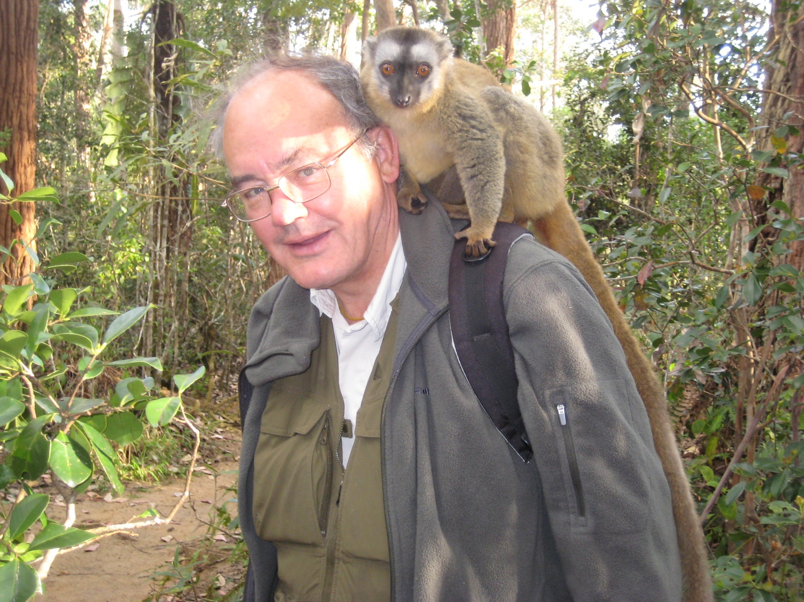 Paul A. Racey

University of Aberdeen, United Kingdom

My interest in bats began as an undergraduate at the University of Cambridge when I answered an exam question set by Donald Griffin, who discovered bat echolocation. My PhD, on reproduction and hibernation in bats, was at a research institute in London Zoo, and included breeding bats in captivity. after a postdoc, also on mammalian reproduction at the University of Liverpool, I moved to the University of Aberdeen, where I spent the rest of my career, and established a research group in bat ecology. After studying all five bat species found in north-east Scotland, my interests moved to the tropics and particularly Madagascar where I established another research group, which evolved into an NGO - Madagasikara Voakajy.

After 50 PhD students, including those in Thailand and Vietnam, and over 200 publications, I retired from the Regius Professorship of Natural History in 2009, and moved to Cornwall in South West England. I have an honorary visiting professorship at the Centre for Ecology and Conservation at the University of Exeter in Cornwall. I still have active research projects in Madagascar and am Co-chair of the IUCN Bat Specialist Group.

****Sherry P. Ramayla

Philippine Science High School-Central Visayas

Argao, Cebu, Philippines

**Conservation Work:**

* Research on Flying Fox in Mindoro and Mindanao and

planning to do research in Cebu

* Baseline data collection on bats and birds in Mindoro, Cebu, Bohol and Mindanao, Philippines
* Conservation education program for high school and elementary students in Cebu, Philippines
* Participates in planning workshops for conservation strategies and studies in the Philippines

**Professional Work:**

* Head of the Research Unit in Philippine Science High School-Central Visayas Campus, Cebu
* Author or co-author of bats and birds studies in Mindoro, Cebu, Bohol and Mindanao, Philippines

**Educational Background:**

* Master of Education in Biology (University of the Philippines Cebu, Philippines)
* Master of Science in Education-CAR (MSU-IIT, Iligan City, Philippines)
* Bachelor of Science in Biology (Mindanao State University-Main Campus)

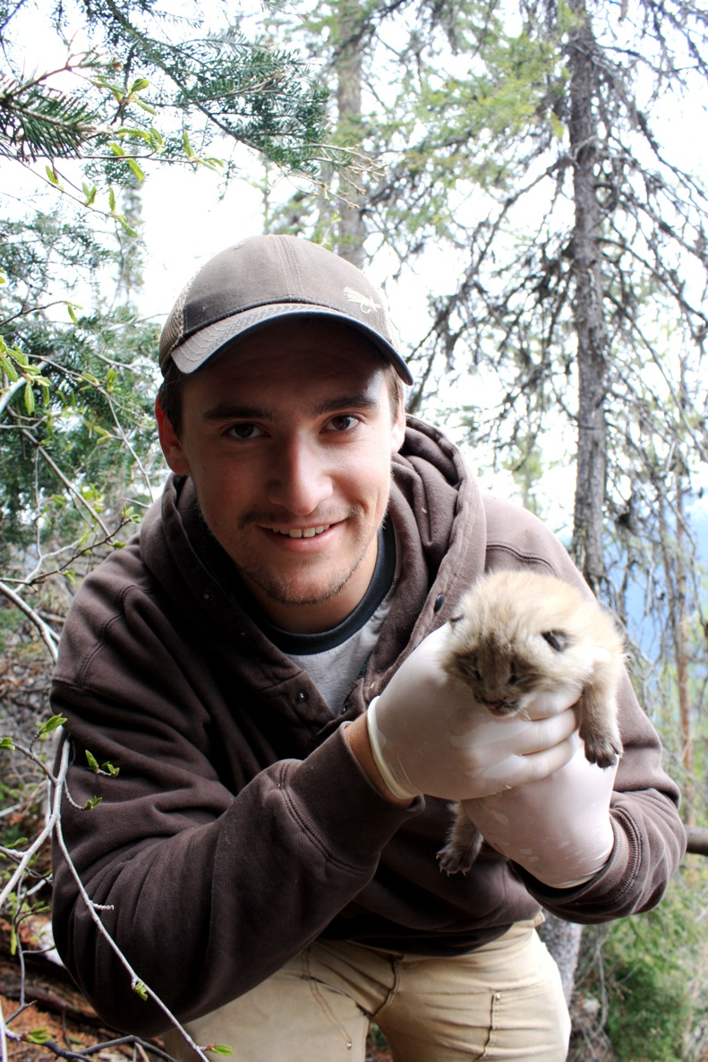Nick M. Rosenberger

University of Montana, USA

Growing up around the deserts of Utah, USA in my youth, I was able to appreciate the fragile, and marvelous possibility of life. Later on I realized the importance of intact ecosystems, so I decided to focus on endangered species conservation.

I am currently an undergraduate student at the University of Montana in the Wildlife Biology program. Here I have had the opportunity to work on the conservation of the Canada Lynx (*Lynx Canadensis*) identifying causes of mortality in juveniles, and also work with Flying Foxes. My Flying Fox work is an internship with Tammy Mildenstein to assist her as well as Dr. Paul Racey, and CE Nuevo with the revision of the Old World Fruit Bat Conservation Action Plan. My main task for the revision is to locate, and compile each publication for each Pteropodid species. Each publication has given me the opportunity to see which Pteropodid species have been studied, and which ones have been ignored.

I am currently interested in non-invasive genetic sampling to identify genetic diversity in Endangered Flying Fox populations, ecosystem services provided by Flying Foxes in a fragmented landscape, and population dynamics of Flying Foxes in response to threats.

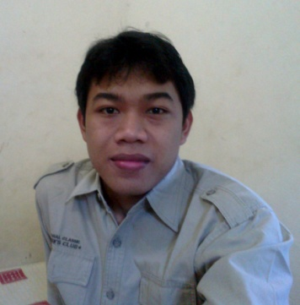

Ronald Andreas Paja Siagian

The Foundation for a Sustainable Ecosystem, Indonesia

I have little experience of research *Pteropus vampyrus* and a few others fruit bats (medium size) that live in caves, when working on a thesis to get my degree. My thesis discusses the hunting and trading of bats by the Batak people in Tapanuli, North Sumatra (Indonesia). I did a survey (November 2009-May 2010) in three districts, namely North Tapanuli, Central Tapanuli and South Tapanuli. At that time I worked with Gabriella Fredriksson, from The Foundation for a sustainable Ecosystem (YEL).

Since April 2011 till now I am working on YEL, for the site Batang Toru (Tapanuli). My main job is to conduct monitoring of flora and fauna in Batang Toru research station. In addition, I also try to follow the issue of environmental problems, such as hunting P.vampyrus problems that occurred 1 time period of the year (seasonal).

Boripat Siriaroonrat

Wildlife Health and Ecology Coordinator, Regional Office for Asia and the Pacific, Food and Agriculture Organization, Thailand

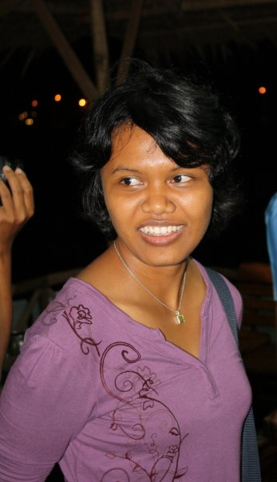Tuanjit Sritongchuay

I’m Tuanjit Sritongchuay, the first year PhD student at Prince of Songkla University in Department of Biology. I’m broadly interested in plant-animal interaction (pollination, seed dispersal), especially bat ecological service. I conducted the pollination ecology of Oroxylum indicum, the early successional plant species, which is solely pollinated by bat in Southern Thailand. My PhD thesis is to work on pollination network in agricultural area, mixed fruit orchard which is unique in South East Asia. Pollinator population decreasing has motivated me to identify the pollinator that play important role in agricultural area. I also hope that my research will aid in the conservation in term of highlighting importance of wide bats and insects.

My role in SEABCRU is student leader in flying fox priority.

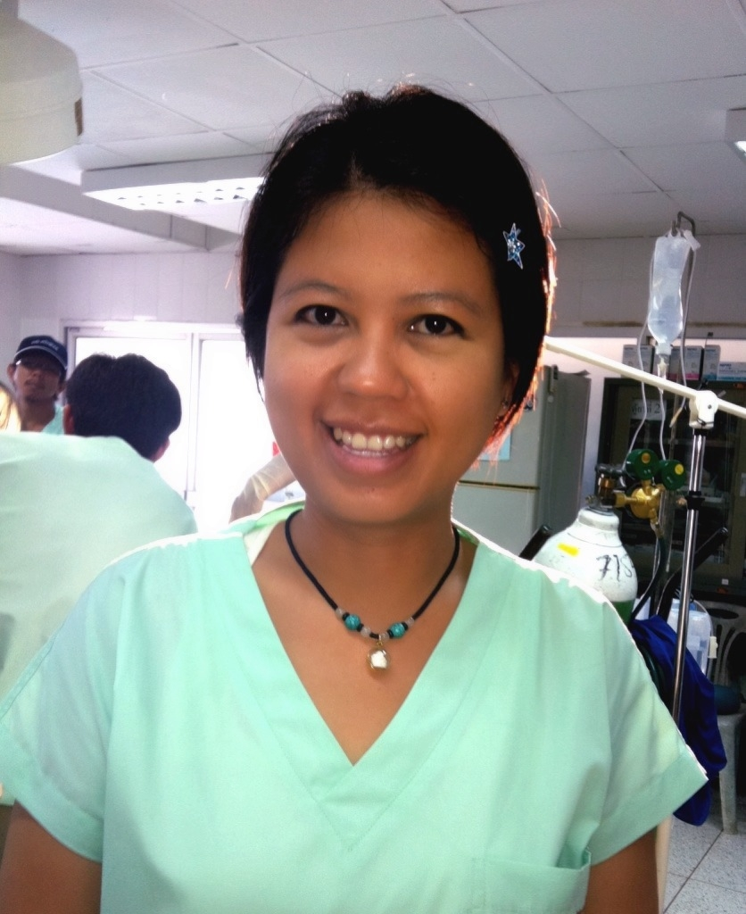

Dao Daraka Tongthainan

Khao Kheow Open Zoo, Chonburi, Thailand

I was interesting in wildlife medicine since I was studying  in veterinary school at Kasetsart University. So I decided to be zoo veterinarian. Finally, I got that job and becomes the first woman veterinarian under the Zoological Park Organization, Thailand. My job is medical service as veterinarian and mammal curator.  I’ve been working at Khao Kheow Open Zoo, Chonburi for 10 years.

Few years ago, I have opportunity to join Dr. Supaporn Wacharapluesadee team from  Chulalongkorn University. On her research about Nipah virus surveillance in bat in many areas of Thailand, she also surveyed Nipah virus in captivities, 3 zoos under the same organization.

 From One health concept is involving 3 part. Human, animal and ecosystem health. Most of emerging infectious disease there are wildlife involving.

In this workshop I expect to have new connection and opportunities to join the research about bat-borne disease in the future.

Nor Zalipah

Lecturer/Phd Student, Universiti Malaysia Terengganu, Malaysia